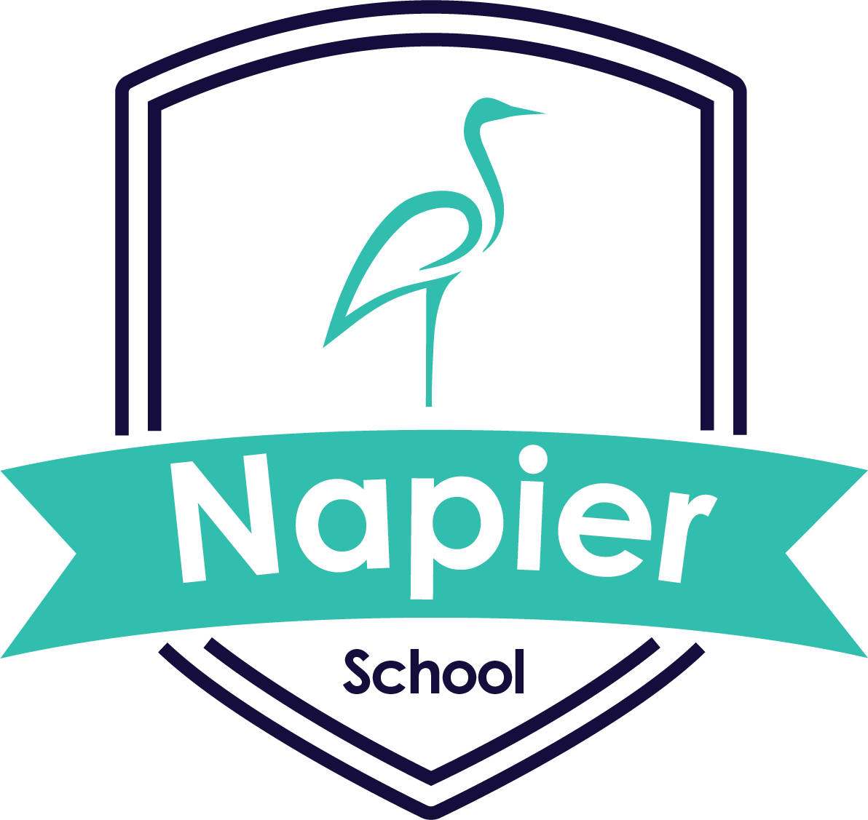

Napier School Uniform

School Uniform consists of:
- Navy Blue round neck sweatshirt
- White Polo shirt
- Navy Blue Jogging bottoms
- (own trainers)

PE kit:
- White round neck T-shirt
- Black shorts
- (own trainers)

Navy blue drawstring PE bag
Navy blue book bag

Uniform with the school logo can be ordered via:
Napier School – Brenda's Schoolwear (brendas.co.uk)

