
Curriculum
Policy

Napier School

2026/2027
Health &
Safety Handbook

Policy Folder: Health& Safety

Health &

Safety Handbook
Policy Folder: Health & Safety

Curriculum Policy
Contents

Introduction……………………………………………………………………………………….. Page 1
Whole School Mission Statement ………………………………………………………. Page 1
Vision………………………………………….………………………………………………………. Page 1
Mission………………………………………….……………………………………………………. Page 1
School Values…………………………………..…………………………………………………. Page 1
Intent …………………………………………………………………………………………………. Page 2
Curriculum Structure …………………………………………………………………………. Page 3
Long Terms Plan ……………………………………………………………………..…………. Page 4
Implementation ………………………..………………………………………………………. Page 4
The Golden Thread ……………………………………………………………………………. Page 5
Curriculum Impact ………………………………….…………………………………………. Page 5 and 6

Introduction
Whole School Statement
At Napier School we recognise that every pupil is unique and that meaningful learning can only take place when pupils feel safe, understood and supported. Our curriculum is therefore rooted in a nurturing, relational approach that prioritises emotional wellbeing, communication and independence alongside academic learning.
We aim to deliver a broad, balanced and personalised curriculum that supports pupils to develop the knowledge, skills and personal attributes required for adulthood and participation in the wider community.
Mission
We commit to unlocking our pupils’ potential for growth and opportunity through a person-centred, high-quality education within a supportive and nurturing environment.
School Values
At Napier School our values underpin all aspects of school life:
- Be Kind
- Be Proud
- Be Brave
- Be You
- Be Curious

These values are embedded throughout our curriculum, relationships and daily interactions.

Intent
The Napier curriculum is designed to meet the complex and diverse needs of our pupils, most of whom have a primary diagnosis of Autism Spectrum Condition and may also experience a range of communication and learning difficulties.
Our curriculum is built around three core principles:
1. Nurture and Emotional Security
We recognise that learning happens best when pupils feel safe, regulated and connected to trusted adults. Our curriculum is therefore informed by:
- Nurture principles
- Trauma-informed practice
- Neurodiversity-affirming approaches
This ensures pupils develop the emotional security required to engage in learning.
2. Personalised Learning
Every pupil follows an individualised learning journey based on their:
- Education, Health and Care Plan
- Developmental stage
- Communication needs
Learning is structured through Personalised Learning Goals (PLGs) which break down long-term EHCP outcomes into achievable steps.
3. Preparation for Life
The Napier curriculum prioritises the development of:
- Communication skills
- Emotional regulation
- Independence

- Social interaction
- Resilience
- Problem solving
- Careers

These skills support pupils to become confident individuals who can access the wider world and participate meaningfully in their communities.

Curriculum Structure
In order to meet the diverse needs of pupils at Napier School, the curriculum is delivered through three flexible pathways.
Pre-Formal Curriculum
The Pre-Formal curriculum supports pupils working at the earliest stages of development.
Learning focuses on:
- Early communication
- Social interaction
- Emotional regulation
- Sensory exploration
- Play-based learning
- Attention and engagement

Semi-Formal Curriculum
The Semi-Formal curriculum supports pupils who are beginning to apply their learning more independently.
This pathway focuses on:
- Communication and language development
- Literacy and numeracy
- Social understanding
- Problem solving
- Independence and life skills

Formal Curriculum
The Formal curriculum is aligned with the National Curriculum, adapted to meet pupils’ developmental stages and individual needs.
Pupils develop subject knowledge in areas such as:
- English
- Mathematics
- Science
- Humanities
- Creative subjects
- Physical development
- RSHE
Learning remains personalised and scaffolded to ensure all pupils can access meaningful challenges.

Long Term Plans
Each term, the whole school focuses on a central topic that guides our lesson planning. Examples of these topics include Changes, Space, and All About Me.
To introduce each topic, the school participates in an Entry Point activity, which is a hands-on or sensory experience designed to engage students and spark curiosity. At the end of the topic, we take part in a Whole School Exit Point, where students reflect on and celebrate what they have learned before moving on to the next topic.
Curriculum Implementation
Teaching at Napier School is informed by a multi-disciplinary approach involving teachers, therapists and specialist staff.
Pupils are assessed on entry and throughout their time at school to ensure learning remains appropriate and ambitious.
Assessment tools include:
- Evidence for Learning
- Phonics assessments
- STAR Reader
- STAR Maths
- Handwriting assessments

The Golden Thread
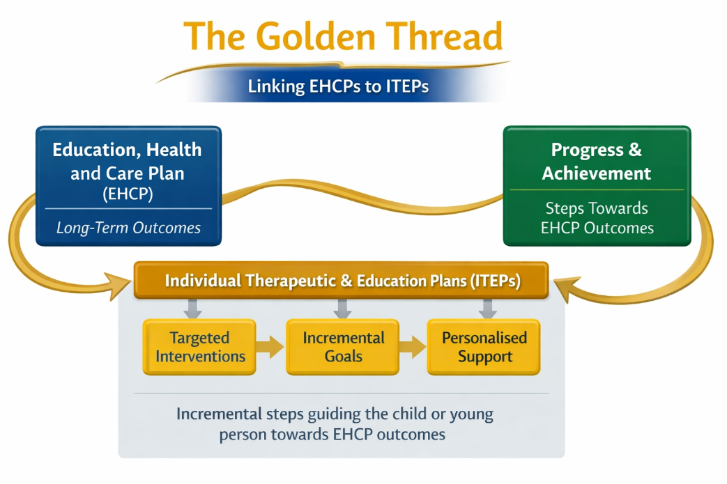
Individual Therapeutic and Education Plans (ITEPs), which are the incremental steps towards the Education, Health and Care Plans (EHCPs) Outcomes. Every pupil that attends the school has an EHCP which outlines the pupils personalised needs, provision to support overcome barriers to learning and sets out long term outcomes within four areas covered by the 2015 SEND Code of Practice: - Communication & Interaction - Sensory & Physical - Cognition & Learning - Social, Emotional & Mental Health

Curriculum Impact
The impact of the curriculum is measured through:
- Progress towards EHCP outcomes
- Progress within PLG targets
- Improvements in independence and communication
- Emotional regulation and wellbeing
- Engagement in learning
- Readiness for next stages of education
Progress is monitored through ongoing formative assessment, observations and pupil progress meetings.

Extended Learning and Enrichment
The curriculum is enriched through:
- Outdoor Learning
- Community visits
- Cultural celebrations
- Therapeutic interventions
- Careers
- School Events
These experiences broaden pupils’ understanding of the world and support the development of cultural capital and independence.

Monitoring and Review
The Senior Leadership Team monitor the quality of curriculum delivery through:
- Lesson observations
- Learning walks
- Planning scrutiny
- Pupil progress meetings
- Curriculum reviews
This ensures the curriculum remains responsive, ambitious and effective in meeting pupils’ needs.



